How to create a report of the number of items requested per week | 

Yoel Kortick
Senior Librarian

ONE
Create a report in the “Requests” subject area

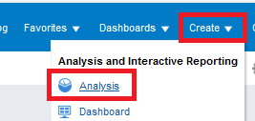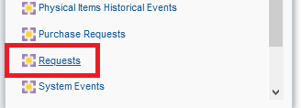

TWO
Display the following fields:

- "Request Measures > # of requests"
- "Request Date > Request Date Start of Week"

THREE
Decide how far back you want the report to include.
Add this field to filter by and then remove it from display after making the filter

- "Request Date > Request Date Filter"

Here we filter by the last 3 months

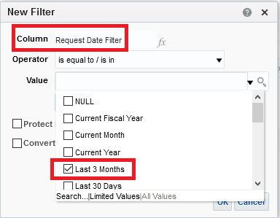

Then we remove it from display

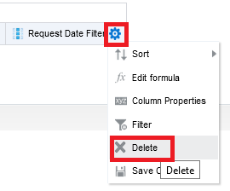

And we still have it in the filter

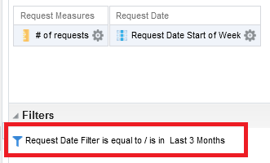

FOUR
Sort the “Request date start of week” descending so that the most recent will be in top:

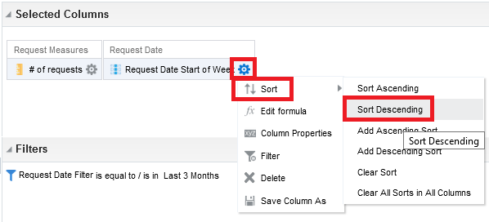

FIVE
Switch to criteria tab and drag the “Request date start of week” column to the left (if it is not already in the left)

Now we have the number of requests per week with the first day of the week

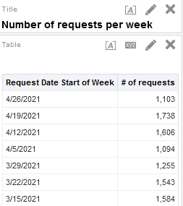

SIX

If you also want the request type then from the results tab drag the following field

- "Request Type > Request Type Description"

To the middle column

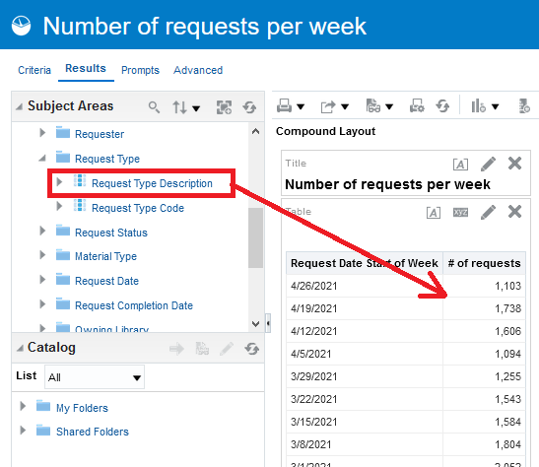

SEVEN

We see all types but we want only “Patron Physical Item Requests”

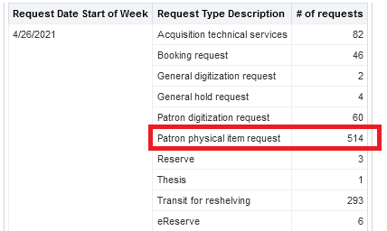

EIGHT

In the criteria tab filter by “Request Type Description = Patron Physical Item Request” then remove it from display

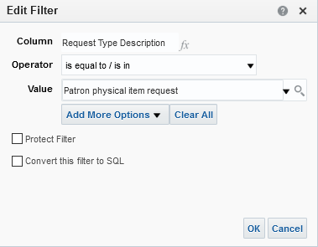

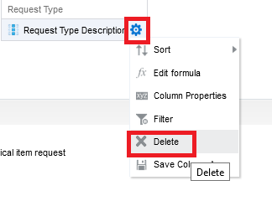

NINE

Now we have number of patron physical item requests per week with the most recent week on top.

